IV. Lafayette-Main District Design Guidelines

A. Purpose
The Salisbury Zoning Bylaw provides for a design review process in order to encourage diverse, high-quality, and attractive commercial developments and mixed-use developments on Lafayette Road, Main Street, and Toll Road, substantially consistent with the Salisbury Master Plan; to meet the goods and services needs of residents and visitors; and to create attractive, organized activity centers on Lafayette Road and Main Street.

The Lafayette/Main corridor is one of the main gateways to the Town of Salisbury, and residents have a vested interest in improving the appearance and functionality of the corridor and maintaining improvements over time. These design guidelines convey to potential developers the community’s vision and hopes for the area, with few technical specifications or prescriptive engineering requirements. The purpose of this format is to allow future designers, engineers, and architects to employ creative or unforeseen methods in pursuit of the desired results clearly summarized here.

B. Procedures and Decision
Lafayette-Main design review is administered by the Planning Board for projects in the Lafayette-Main Commercial District. Where site plan review is required, the design review process shall be conducted in conjunction with the site plan approval process. Both design review and site plan review allow the Town to work with developers to ensure that new development is in keeping with local goals and priorities, even when the proposed use is allowed by right.

In making its determination, the Planning Board shall find that the applicant has met all of the following Design Guidelines, unless waived. The applicant shall, as part of their initial submission or as soon as an issue arises, submit to the Board in writing an explanation for why a particular standard as described in this section is impossible, will render the project infeasible, or will run counter to the purpose of these guidelines or the zoning bylaw. The Board, at its discretion, may choose to waive or modify any of the guidelines herein based on such a request.

To assist with their technical review, the Board shall obtain the services of a Design Review Consultant with sufficient professional architecture and landscape design experience to render an opinion on an application’s compliance with these Design Guidelines.

C. Submittal Requirements
When a project requires Design Review, the proponent must submit materials in compliance with Section III “Site Plan Review Requirements” of the Planning Board’s Rules and Regulations, including the project narrative submittals in subsection B.3. The following additional materials shall be required for Design Review, unless waived by the Board:
1. For projects involving changes to existing buildings, the following additional materials are required:
a. Photographs of existing buildings showing location of proposed alterations/renovations and of adjacent areas.
b. Landscaping plan showing all proposed changes and describing all materials including plantings.
c. Manufacturers’ brochures with illustrations and specifications for new materials, components, or assemblies to be used.
2. For projects involving construction of new buildings, the following additional materials are required:
a. Manufacturers’ brochures as described above.
b. Photographs of adjacent buildings.
3. Drawings need to be professionally prepared and must:
a. Be drawn to scale.
b. Show all exterior features completely and accurately.
c. Show finish grades and floor elevations.
d. Indicate all materials, colors, and unusual details.
e. Be legible.
f. Trees and other landscaping shown on the plan shall be shown at their expected height and size at a point in time no more than two years from the initial planting
4. Examples of previous work from architect and/or owner.
5. All submitted photographs must be recent, in color, and no smaller than 8 by 10 inches. Several different views are necessary, including those of adjacent properties.
6. Samples, models, mock-ups, etc., may be requested by the Planning Board.

D. Pedestrian Experience
- Projects should be designed to provide efficient and safe pedestrian circulation within the site, on sidewalks and street crossings, and between adjacent properties.

- Pedestrian areas should be lit during business hours, and the scale and design of light fixtures should be attractive, and match proposed or existing architecture. Light poles for pedestrian areas should not exceed 15 feet in height.

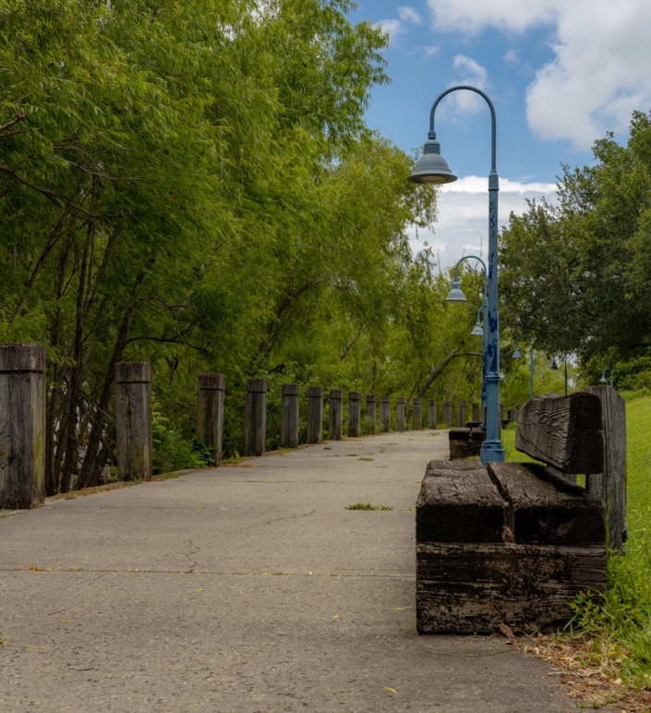
Pedestrian-scale lighting and benches along a wide walking path.

Nighttime lighting along a walkway, low to the ground and not overly harsh.

- Whenever possible, energy-efficient lighting such as LEDs should be used. Pedestrian lighting and lights in parking and vehicular access roads should have clearly distinguishable coloring to visually separate the areas at night.

- Clear physical separation between pedestrians and vehicles should be maintained for safety and comfort, both along major roads and in the design of the site’s internal circulation.

- The streets should have well-maintained sidewalks with native foliage and street trees to provide shade and separate sidewalks and walking paths from traffic. Trees provide shade and invite pedestrians to spend time walking along the sidewalk.

- Pedestrian paths should be maintained between principal buildings, parking areas, and the sidewalk, both on-property and between neighboring sites. Amenities such as benches are encouraged.

- Bicycle lanes and other bike infrastructure (such as bicycle parking places and bike racks) should be included.

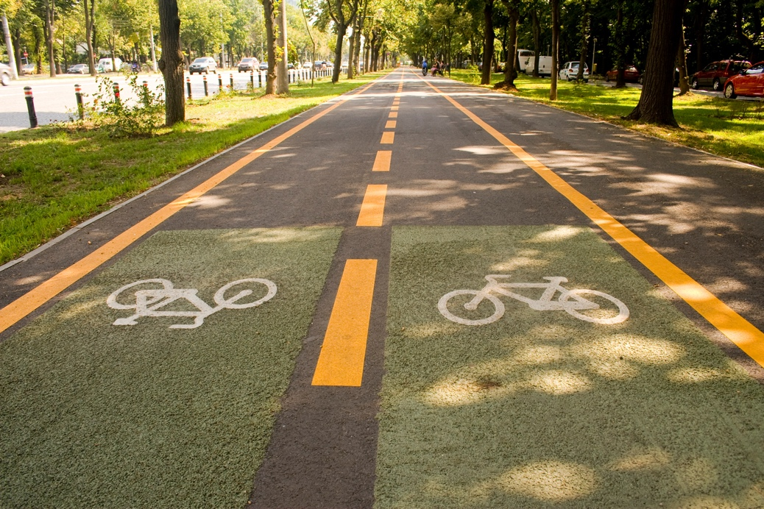
Two-way bike lanes with a pedestrian lane, separated from the road by a green strip. Trees lining the path provide shade.

- Walking paths, curb cuts, crosswalks, and bicycle lanes should be clearly designated with varied colors and pavement textures, and well-maintained. Granite curbing should be used wherever possible.

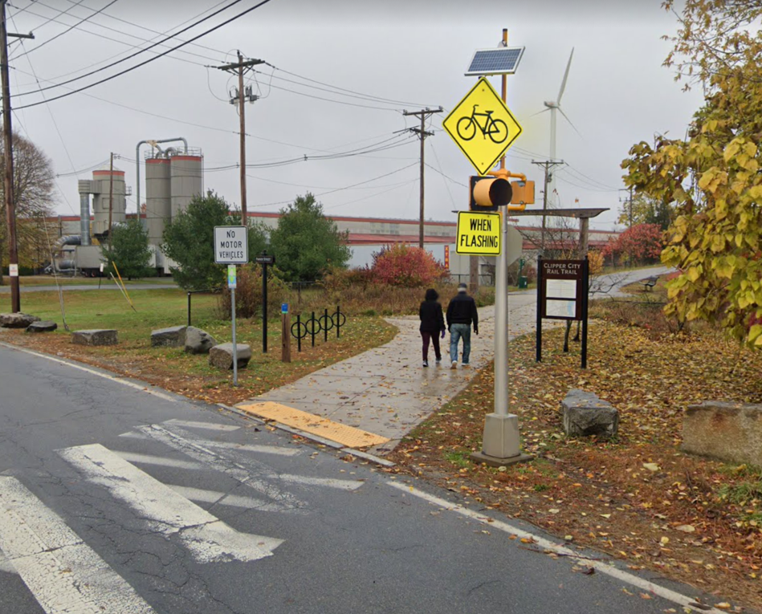
Clearly marked and signaled crosswalk connecting a well-maintained walking path with bike racks and greenery. (Parker St., Newburyport)

- The width and construction material of pedestrian and bicycle lanes should be able to accommodate use by a wide range of mobility aids and devices. Connections between different areas (e.g. between a parking lot and walking path) should be usable by wheeled devices. Accommodations for pedestrians with vision impairments should be incorporated into walking paths and crossings.

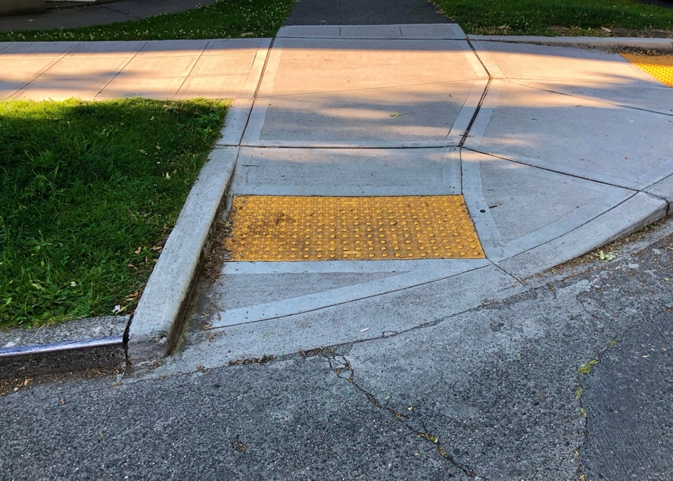
Gently sloped curb cut with raised surfaces to assist visually impaired pedestrians.

Discouraged
- Exterior nighttime lighting should not be overly harsh and industrial feeling, or disproportionately intrude on neighboring residential properties. Outside of business hours, commercial and industrial uses should avoid harsh interior lighting that might impact neighboring properties.

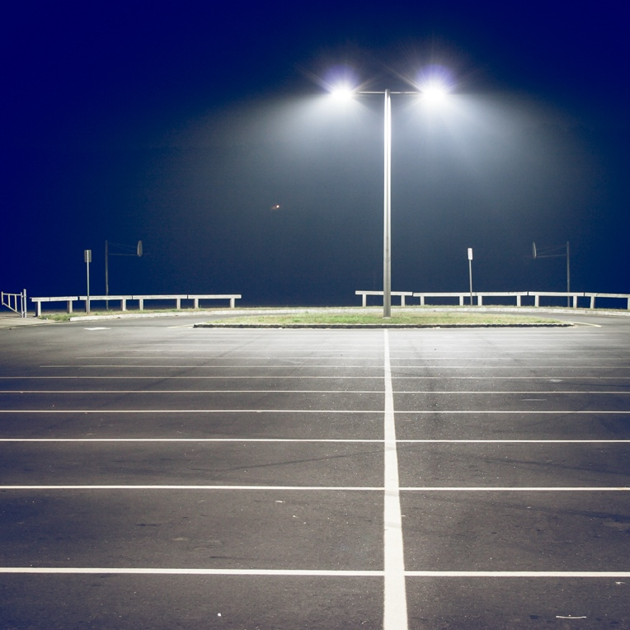
Parking lot lit by tall, harsh floodlights.

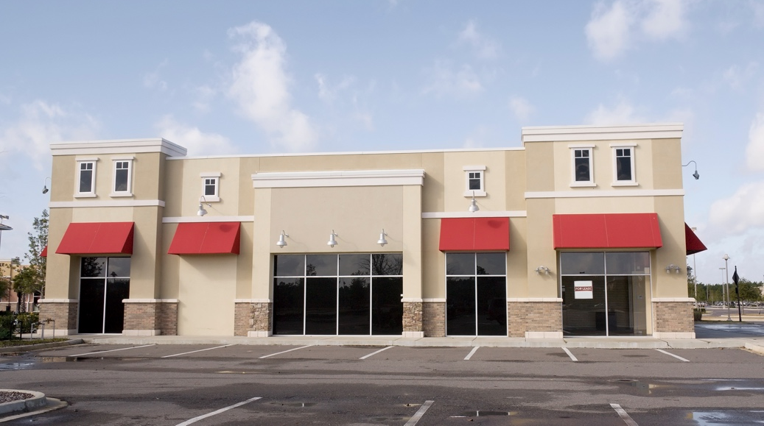
Commercial building with appropriately scaled lighting fixtures. The lack of landscaping in the image is undesirable, however.

- Invasive or non-native plant species should be avoided.

- Pedestrian and vehicle access should not be adjacent without adequate and clearly separation.

E. View from the Road
- Foliage in the planting strip should provide a clear separation between pedestrians and the road, both for pedestrian safety and comfort as well as creating a positive image of Salisbury for drivers.

- Plantings should consist of shrubs and flowers that will not obscure pedestrians from the point of view of drivers.

- Any part of the front yard not utilized for another purpose should be well-landscaped, with a grass or mulch surface and featuring flowering plants, shrubs, and shade trees. Projects close to the road should provide street furniture like benches or seats.

- Signage should be as simple and uncluttered in design as the content will allow. Signs should be attractive and made from natural materials such as wood or stone. See Section 214 of the Town of Salisbury’s General Bylaws for regulations governing signs.

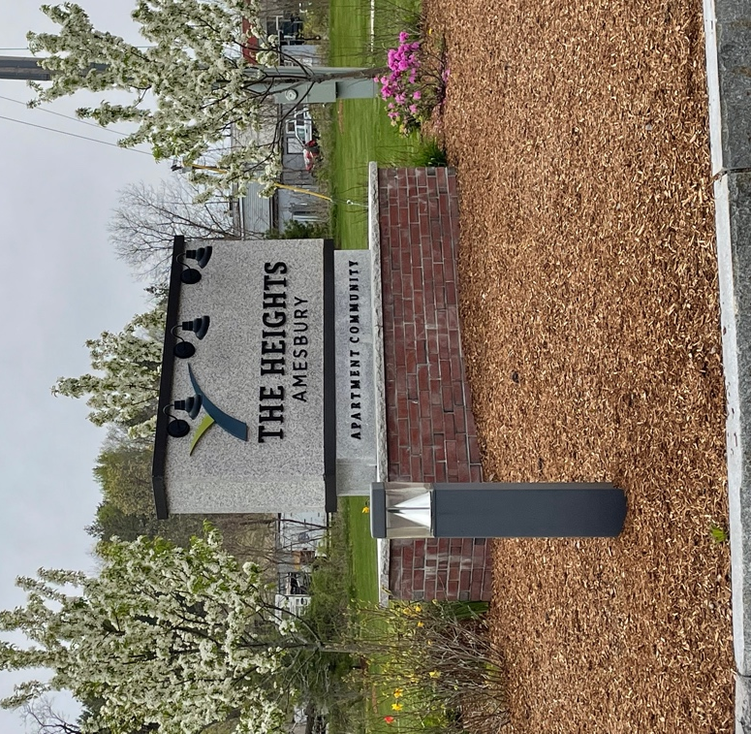
A stone-and-brick sign without flashy or bright colors. Other desirable elements include landscaping taking up unutilized space, pedestrian-level lighting, and granite curbing.

- Parking and loading areas should be to the side or back. If parking must be in the front of the building, plantings should provide a visual buffer between parking lots and the street.

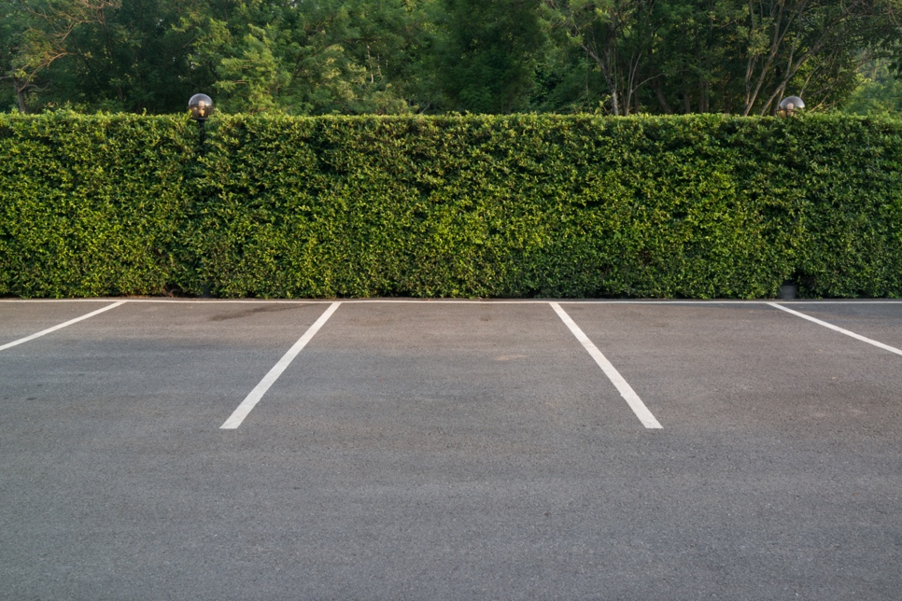
Parking lot screened from view by a planted barrier.

- Utilities, mechanical equipment, and dumpsters should be located to the side or back of the property and should be screened by a fence or other barrier made from materials compatible with the site’s primary structure, so as not to be visible from the road. Utilities may also be located on the roof of a building if they are adequately screened from street-level view.

- The building façade need not be entirely obscured but should be broken up by the plantings (For preferred building design and materials, see “Property Character”).

Discouraged
- Sites where the visual character from the road is primarily parking lots or unbroken building façade

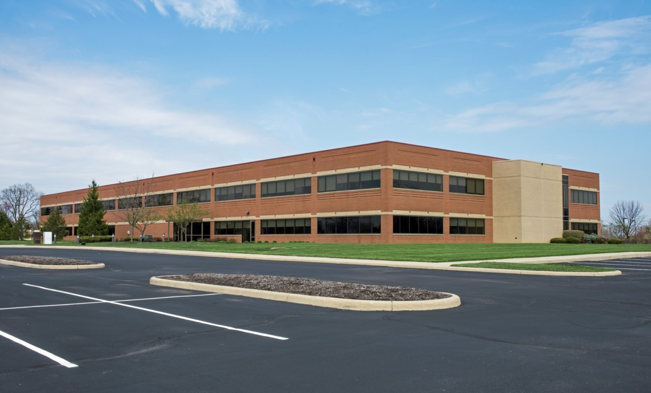
A large blocky building with few building elements to break up the façade. Sprawling parking lots and a lack of attractive landscaping are also undesirable.

- Bare dirt or gravel, or yards overgrown with weeds.

- Flashy, distracting, or obnoxious signage.

- Storage, utilities, or parking in front of the building, to the extent practical.

F. Property Character
- Where a lot contains a single principal structure, utilities accessory buildings and structures should be located behind or to the side of the main building. If a lot contains multiple principal structures, accessory structures and utilities should be located on whatever side of the main building is least visible to high-traffic pathways and well-screened with materials compatible with those used for the appurtenant building.

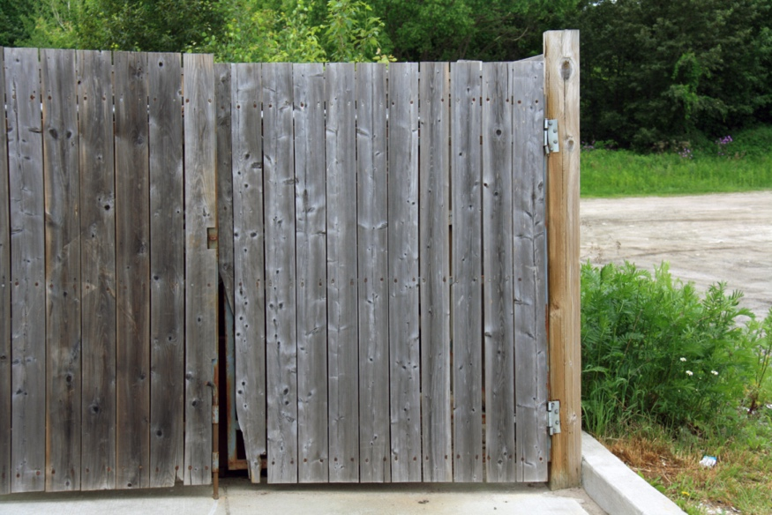
Dumpster screened from view by a simple wooden fence.

- Exterior lighting should be of the cutoff luminaire type and be consistent with the overall architectural theme of the development. Accessways, parking areas, and pedestrian walkways should have adequate lighting for security and safety reasons.

- On-site parking lots should be broken up by vegetated median strips and crosswalks for pedestrians.

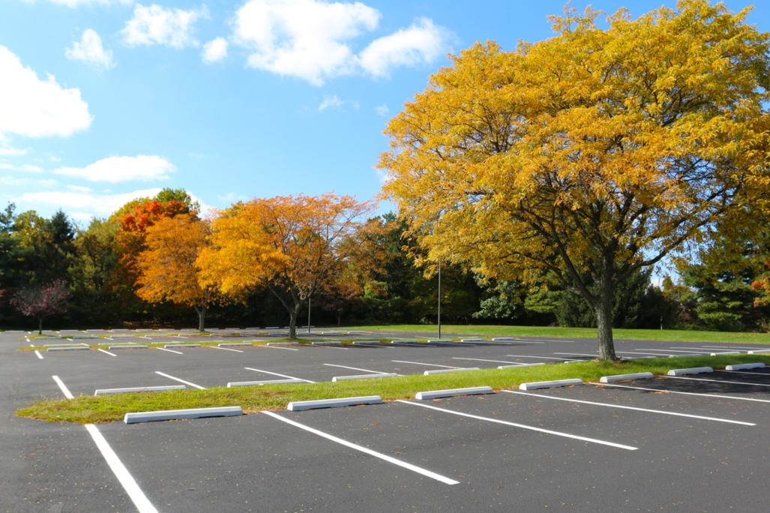
Parking lot with grassy medians and shade trees placed throughout.

- Buildings should be constructed out of natural materials, or reasonable approximations of natural materials. Design should incorporate traditional New England architectural elements wherever possible and avoid "boxy" industrial designs and uninterrupted massing.

Traditional wooden siding historically used in Salisbury and across New England.

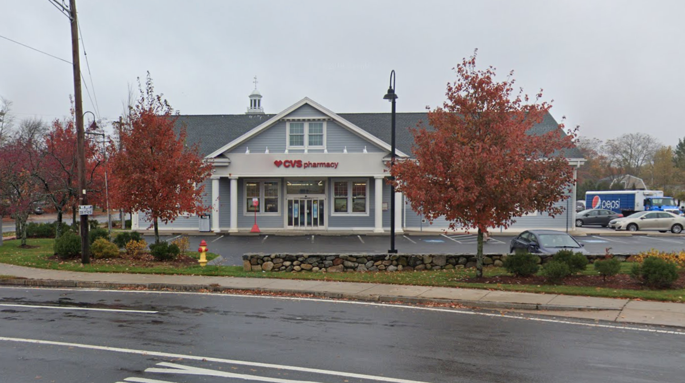
Traditional architectural elements utilized for commercial buildings. Attractive landscaping provides a separation between the property and the road. (CVS on Lafayette Road, Salisbury)

- For large-scale development where traditional designs are not feasible, flat roofs should be adorned with parapets or other architectural features that provide the sense of a “cap” to the building, unless the need to locate utilities on the roof renders such features infeasible.

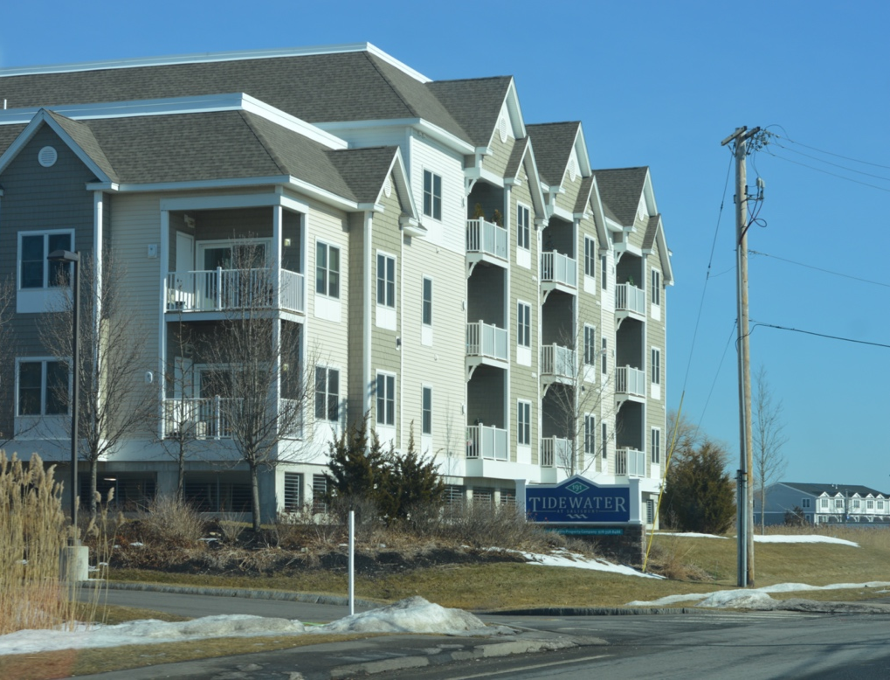
A multifamily development that nonetheless incorporates traditional architectural elements like gables and a variety of colors and surfaces to break up the façade. (Tidewater at Salisbury, Beach Rd., Salisbury)

- Site design should prioritize preservation of distinctive natural features and sensitive areas, including but not limited to:
- flood hazard areas
- floodplains
- steep slopes
- mature woodlands
- wetland buffer zones
- vernal pools
- prime farmland
- large open meadows
- stone walls
- critical wildlife habitats
- priority habitats (as designated by Natural Heritage and Endangered Species Program)
- important cultural features such as historic and archaeological sites, heritage landscapes and scenic views

- The amount of permanently protected open space on each parcel should be maximized

Discouraged
- Flood and area lighting is discouraged.

- Large, unbroken empty areas of little visual interest or appeal.

- Sites that are mostly paved over for parking and vehicular access.

- Cutting down mature trees and other major vegetation.

G. Stormwater and Environmental Impacts
- There should be no measurable or significant impact as to existing vegetation, topography, wetlands, and other significant natural features.

- The site plan shall include adequate provisions for measures to prevent pollution of surface water or groundwater, minimizing erosion and sedimentation, and measures to prevent changes in groundwater levels, increased runoff, and potential for flooding.

- Low-impact Development (LID) principles should be employed wherever possible, in every aspect of site design. LID strategies minimize pollution from stormwater runoff by emphasizing the importance of reducing paved areas, which prevent groundwater recharge and contribute contaminants to our water supply, in favor of utilizing the natural services of plant and soil processes for water filtration
- Notable LID techniques that developers should consider include:
- Rain gardens and bioswales:
- Green roofs:
- Permeable pavement:
- Paving reductions:
- Rain barrels and cisterns:
- Conservation design:
- And many other innovative techniques.

Permeable pavement provides gaps in impervious surfaces to increase stormwater absorption.

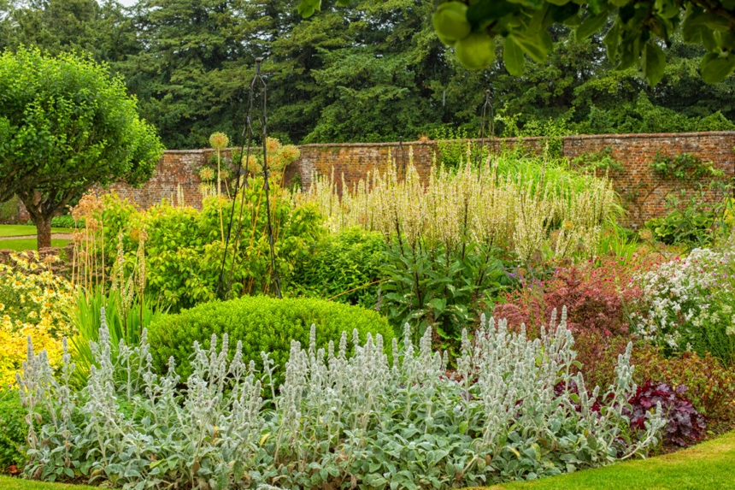
Rain gardens are low-lying vegetated areas that collect and absorb rainwater.

- Impervious surfaces should be minimized, and where unavoidable strategies such as permeable pavement (see above) should be utilized to increase permeability.

- Applicants shall propose a stormwater operation and maintenance plan to be maintained in perpetuity.

Discouraged
- Large amounts of impervious area.

- Large-scale removal of trees or other vegetation.

H. Corridor Cohesion

Preferred
- Site design should take into account existing properties on either side. Connections between properties and unifying design elements are encouraged. Planting types and locations, types of lights and pedestrian/bicycle fixtures, and connections between pedestrian walkways should all be considered.

- Where multiple primary structures are located on the same site or on adjoining parcels under common ownership, like or compatible uses should be well integrated on a site and have access to common paths and open space. Incompatible or incongruous uses should be set back from one another and screened with foliage or wooden fencing.

- Any newly constructed road or way should include pedestrian and cyclist accommodations and connect to adjacent roads, trails, and bike paths that connect to any existing adjacent ways and paths. Two-way foot and bicycle traffic should be included where feasible. Walkways, trails, and bike paths should also be provided to serve the interior of the site and connect the primary structures and open space amenities.

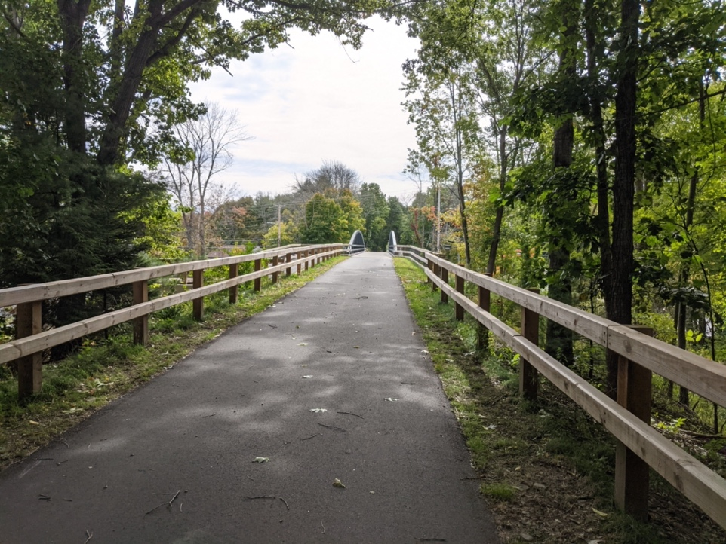
Walking trail with access to and from adjacent properties. (Old Eastern Marsh Trail, Salisbury)

- New commercial construction should avoid disproportionate impacts to preexisting residential abutters through proper buffers, screening, and lighting.

Discouraged
- A patchwork of clashing architectural and landscape styles.

- A corridor configuration that does not encourage walking throughout its entire length.

- Sites that are completely isolated from one another and from the main Lafayette-Main corridor.

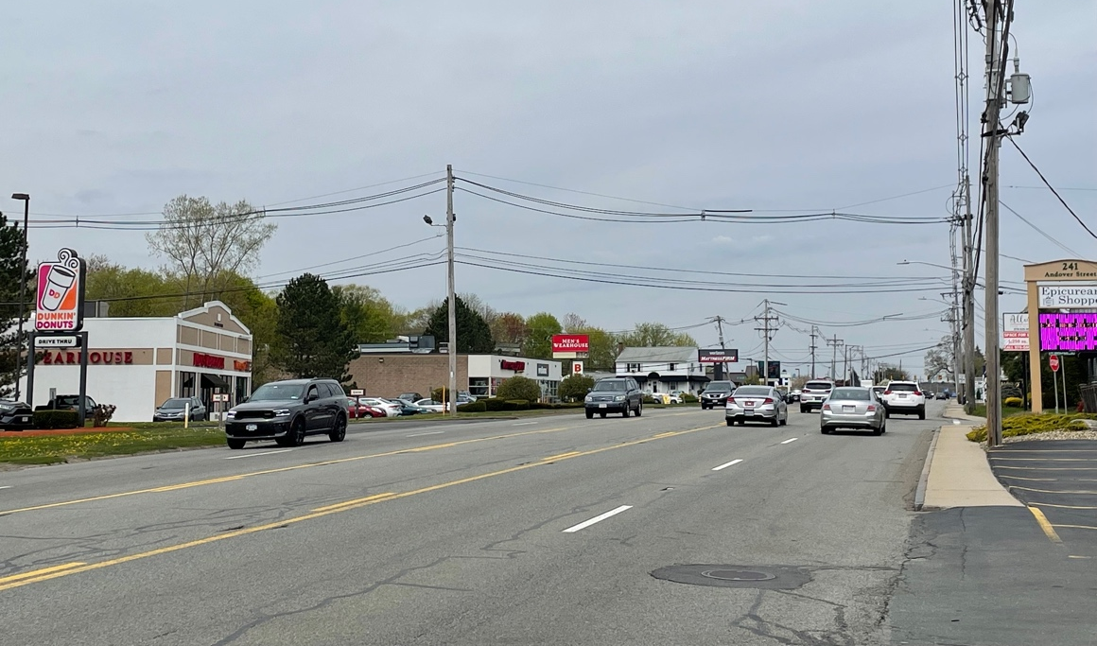
“Strip” style commercial corridor with loud signage, little to no screening, and sidewalks directly adjacent to traffic. Little connectivity between sites.

